**SWMM_HEC-RAS_StreamEcosystem (SHRSE) Model Python Notebook User’s Manual/README**

**Introduction**

Welcome to the user's manual for the Python notebook designed to operate the SWMM_HEC-RAS_StreamEcosystem (SHRSE) model. SHRSE is an innovative integrated model that enables the assessment of urban landscape decisions' impacts, such as green infrastructure implementation and land use changes, on urban stream ecosystems and nutrient processing.

**Model Overview**

SHRSE combines the capabilities of multiple modeling tools. It employs the SWMM (Stormwater Management Model) as a watershed hydrology and water quality model. SWMM generates flow data that serves as input for HEC-RAS, the channel hydraulic model. HEC-RAS transforms flow data into essential channel hydraulic parameters, including velocity, volume, and benthic area. These parameters, along with nutrient concentrations from SWMM, are used as inputs for the stream ecosystem model.

**Intended Audience**

This Python notebook is intended for use by hydrology students and professionals who have a familiarity with python scripting and interpolation techniques, SWMM, HEC-RAS, and the mathematical equations used in stream ecosystem modeling (please refer to the provided references).

**Organization**

The notebook is structured into five distinct code blocks, each serving a specific purpose:

Code Block 1: This section loads the necessary Python libraries required to execute subsequent code blocks in the notebook.

Code Block 2: Here, you will find instructions to load the essential input data, encompassing subbasin and stream ecosystem time-series data.

Code Block 3: This segment configures the SWMM input file, initiates SWMM simulations, and retrieves pertinent results for further use by HEC-RAS and the stream ecosystem model.

Code Block 4: In this section, you will find the stream ecosystem functions, all meticulously derived from the literature sources listed in the references section of this document.

Code Block 5: Finally, this block executes the channel hydraulic and in-stream ecosystem models.

**Customization**

Please note that the current notebook is parameterized for the upper Meadow Creek watershed in Charlottesville, Virginia. However, it can be tailored to fit other watersheds once you have familiarized yourself with its functionality.

**Code Block 1 Load Required Libraries**

Code block 1 loads the required python libraries (python version 3.9.6 at the time of this writing). The major libraries include SWMM API (<https://pypi.org/project/swmm-api/>­), pandas (<https://pandas.pydata.org/>), NumPy (<https://numpy.org/>), and datetime.

**Code Block 2 Input Subbasin, Channel, and Time-Series Data**

Code block 2 loads the input subbasin and time-series data required to execute the SHRSE model. Input subbasin data includes land use allocations for each subbasin, a steady-state hydraulic lookup table derived from a local HEC-RAS model, hourly photosynthetically active radiation (PAR) data, daily estimates of detritus or leaf-litter carbon, nitrogen, and phosphorus deposition into the stream water column form land sources, daily temperature for each stream zone, and additional green infrastructure parameters for each subbasin. All of these data are input in CSV format. See the following paragraphs to further information on how this data is retrieved and formatted.

**Subbasin Land Use Allocations**

To work with this data, it's essential to have a pre-existing SWMM model set up for your study area. Within this model, you should have allocated specific land uses to each subbasin as part of the water quality model. In the upper Meadow Creek example, we've identified five distinct land use categories: Impervious-Roads, Impervious-Commercial, Impervious-Residential, Grasses, and Tree Canopy. For customization to other watersheds, feel free to group land uses according to your preferences. You can determine these compositions by utilizing geographic information systems (GIS) data specific to each subbasin within your model. For reference on how to format your land use allocation file based on percentages, please consult the "LandUse_Subbasin_Percentages.csv" file.

**Steady-State Hydraulic Lookup Table Derived from a Local HEC-RAS Model**

To utilize this data, it's necessary to have an established HEC-RAS model configured for your study area. HEC-RAS uses a digital elevation model to generate a summary of cross-section hydraulic information based on water level. To access the "summary of output tables by profile," as shown in Figure 1, refer to your HEC-RAS model. Figure 2 displays the "summary of output tables" for select reaches employed in the upper Meadow Creek model.

Navigate to 'Options > Reaches' to choose the reaches containing all the cross-sections in your stream model. To export this information into a CSV file, go to 'File > Copy to Clipboard (Data and Headings)' and paste it into an empty CSV file. This CSV file should encompass the steady-state flow hydraulics for the cross-sections you wish to incorporate in your model.

To compute the flow depth, subtract the 'Min Ch El' value from the 'W.S. Elev.' Each cross-section offers nine flow measurements alongside corresponding flow hydraulic parameters. Volume is calculated by multiplying the cross-section area by the length of each cross-section, which is 30-meters in the upper Meadow Creek model. In the upper Meadow Creek model, we derived depths ranging from zero to approximately 2.7 meters in 0.1-meter increments using interpolation techniques in Python. Refer to the file named C:\Users\robhe\Downloads\Python-SSHBS\MC_All_XC_SSHBS_Inputs.csv for proper formatting of this data.

**Figure 1**: HEC-RAS model Screenshot showing where to access the “summary of output tables by profile’ data (as shown by the red arrow) once a HEC-RAS model is constructed for the study area.

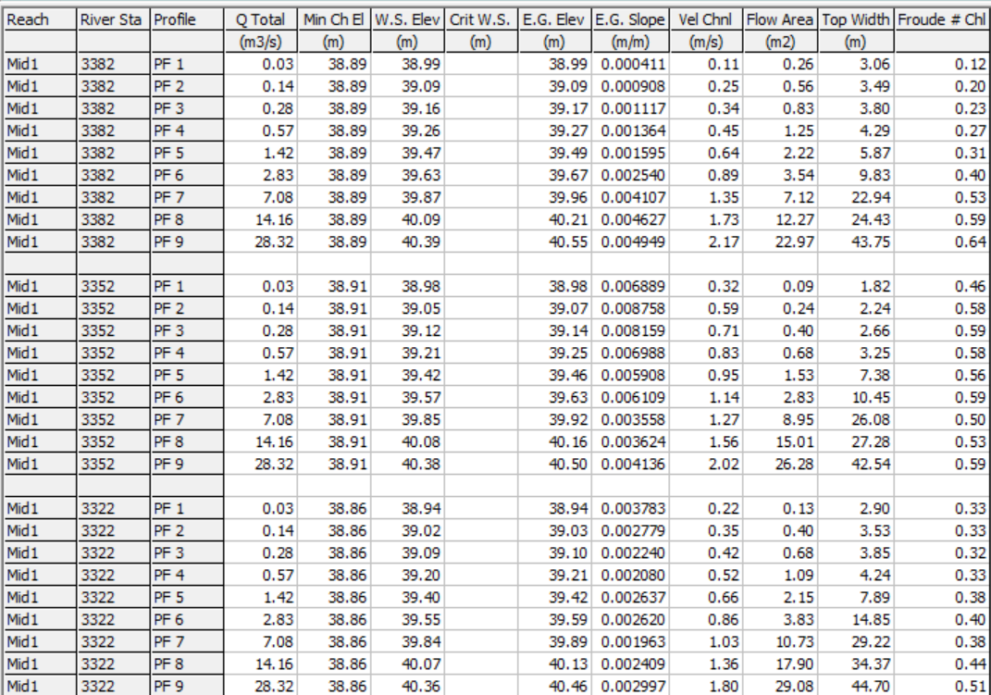

**Figure 2:** Summary of output tables by profile for cross-sections 3382, 3352, and 3322. This data is the steady-state channel hydraulic look up table that is used to convert flow from the watershed to channel hydraulic parameters.

**Photosynthetically Active Radiation (PAR) Data Input File**

Hourly PAR data is utilized in the computation of algal photosynthetic activity and primary production at the streambed. You can acquire this data from sensors, like we did for the upper Meadow Creek area, or utilize model results where applicable. While it's possible to obtain PAR data for various reach sections in the stream, our upper Meadow Creek example specifically utilizes PAR data at one location. To ensure the proper format of this data, refer to the "MC_HourlyPAR_2021-2022.csv" file.

**Estimation of Daily Detritus/Leaf Litter deposition to the Stream Water Column from Watershed Sources**

In cases where daily deposition rates of detritus/leaf litter and C:N:P ratios are not directly measured; these values are approximated based on similar patterns outlined in Webster et al. (2016). We assume that detritus carbon, nitrogen, and phosphorus deposition remains constant on most days, with an increase during leaf-fall periods, particularly in the early fall months in the Mid-Atlantic region. When applying this method to another watershed, it's essential to adjust the leaf-fall periods according to the specific region of your study. While the estimated patterns for detritus and leaf litter deposition are generally consistent across all areas in the study region, their magnitudes may vary depending on the level of riparian canopy at each reach zone. Figure 3 illustrates this variation, where the blue data represent calibrated leaf litter deposition rates for reach zones with canopy cover, and the orange data show calibrated rates for a reach zone with minimal riparian canopy. The magnitudes of these rates are calibrated with respect to stream ecosystem respiration. For the correct format of estimated detritus/leaf litter input data, refer to the "Estimated_Detritus_2021-2022_Calibrated.csv" file.

Figure 3: Estimation of Daily Detritus/Leaf Litter Carbon Deposition at Three Different Reach Zones. The data plotted in blue are reach zones with more riparian tree canopy than at the data plotted in orange as calibrated against ecosystem respiration.

**Input Daily Temperature Data**

Daily temperature data is utilized in the computation of several stream ecosystem processes. You can acquire this data from sensors, like we did for the upper Meadow Creek area. For the upper Meadow Creek subbasin, we obtained temperature data recordings at the three reach zones under consideration. Temperature was sampled every 15-minutes by sensors, and the data was averaged to daily values. To ensure the proper format of this data, refer to the " MC_DailyTEMP_2021-2022.csv" file.

**Miscellaneous Green Infrastructure Parameter Input Data**

This CSV file is designed to facilitate the creation of green infrastructure scenarios when setting up and running the SWMM model. In the upper Meadow Creek model, this file is employed to establish the maximum decision space for rain gardens and green roofs. We assume this space to be equivalent to the number of residential parcels and commercial roof space available in each subbasin, respectively. The CSV file, labeled "LIDPotential_Parameters.csv," corresponds to this specific parameterization. It's important to note that the contents of this file, or even the file itself, may not be required or suitable for use in other study areas.

**Code Block 3 SWMM Input File Parameterizes and Simulation**

Code block 3 serves a crucial role in the framework, as it handles the parameterization, execution, and data extraction from the SWMM model for the watershed study area. However, it's important to note that a well-calibrated SWMM ".INP" file is required for this step. Within code block 3, additional parameterizations are made, including the specification of groundwater and storm event mean concentrations for nitrogen and phosphorus. In the upper Meadow Creek SWMM model, a water quality model for runoff (without a buildup component) and a groundwater quality model are employed, both linked to terrestrial land uses. This section of the code also provides the flexibility to introduce features like raingardens, green roofs, and the conversion of impervious areas to green spaces in each subbasin. These parameterizations are saved in a new ".INP" file, which is executed using the SWMM API python library. Once the model simulation is complete, code block 3 generates water and nutrient mass balance data for groundwater and runoff within each subbasin. Additionally, after the simulation, code block 3 a allows for the adjustment of nutrient treatment efficiencies for existing ponds at the outlets of subbasins, which are applied to the nutrient and mass balance computations from the subbasins. These computations are essential inputs for the channel hydraulic and stream ecosystem model.

**Code Block 4 Writing of Stream Ecosystem Functions**

Code block 4 plays a crucial role by generating stream ecosystem functions, drawing from established literature sources (refer to the references section in this document). These functions encompass various ecosystem processes, including algal uptake, primary production, ecosystem respiration, denitrification, microbe immobilization, miner uptake, and benthic algae/detritus entrainment and deposition. The code block also includes comments that indicate the literature source for each specific process. It's important to note that some values may require calibration, as the values provided in code block 4 are tailored to the upper Meadow Creek watershed and may need adjustments to suit different study areas.

**Code Block 5 Execution of Channel Hydraulic and In-Stream Ecosystem Models**

Code block 5 comprises a Python script for the channel hydraulic and in-stream ecosystem models. The script is organized into several "for loops" that carry out the integrated model's computations over specific groups of HEC-RAS cross-sections. Each group, referred to as a "group_list," is defined by the locations where tributaries join the main stem of the stream. These tributaries alter the boundary conditions for each "group_list," necessitating separate "for-loop" segments for calculating channel hydraulic and stream ecosystem functions.

Within each "for-loop," the process begins by establishing the reach zone, which dictates where input data is extracted from the input data files along the stream. The model then iteratively executes flow hydraulic and ecosystem functions across each cross-section within the "group_list," progressing from upstream to downstream and covering each day of the simulation period.

The first calculation in each "for-loop" focuses on the water and nutrient balances entering the stream at the initial cross-section of the "group_list." For the first "group_list" in the upper Meadow Creek model, these calculations rely on input data from two SWMM subbasin tributaries. However, subsequent "for-loop" calculations are based on inputs from a single SWMM subbasin tributary and water and nutrient inputs from the segments immediately upstream of the new "group_list."

The outputs from these water and nutrient mass balance calculations are subsequently used as inputs at the first cross-section within each "group_list." These inputs are employed to compute channel flow hydraulics in accordance with the HEC-RAS lookup table values for each cross-section and the nutrient mass within the water column. It's important to note that channel flow is considered constant within each "group_list" on a daily basis, while the flow hydraulics differ for each cross-section depending on the specific channel shape, as determined by the HEC-RAS model.

Upon calculating the initial water column nutrient mass at the most upstream part of the "group_list," subsequent changes in water column nutrient mass are governed by the stream ecosystem functions as the model progresses from upstream to downstream. In simpler terms, the boundary conditions for nutrient masses at each cross-section are composed of the nutrient masses computed at the cross-section immediately upstream. The stream ecosystem functions are then applied using these boundary conditions, updating the water column nutrient mass and concentrations as the model proceeds from upstream to downstream.

Ecosystem function equations are employed at two distinct time points within each "for-loop." The first instance occurs on the initial day of the simulation, while the subsequent instances take place every other day thereafter. The ecosystem functions for the first day are initiated with pre-simulation conditions, which are established in code block 4. For all the following days, the ecosystem variables at the conclusion of the preceding day are used as the initial conditions for the computations on the current day.

**Stream Ecosystem Function References**

Boston, H. L., & Hill, W. R. (1991). Photosynthesis-light relations of stream periphyton communities. 36(4), 644–656

Lin, L., Reisinger, A. J., Rosi, E. J., Groffman, P. M., & Band, L. E. (2021). Evaluating Instream Restoration Effectiveness in Reducing Nitrogen Export from an Urban Catchment with a Data-Model Approach. Journal of the American Water Resources Association, 57(3), 449–473. https://doi.org/10.1111/1752-1688.12922

Mulholland, P. J., Helton, A. M., Poole, G. C., Hall, R. O., Hamilton, S. K., Peterson, B. J., Tank, J. L., Ashkenas, L. R., Cooper, L. W., Dahm, C. N., Dodds, W. K., Findlay, S. E. G., Gregory, S. V., Grimm, N. B., Johnson, S. L., McDowell, W. H., Meyer, J. L., Valett, H. M., Webster, J. R., … Thomas, S. M. (2008). Stream denitrification across biomes and its response to anthropogenic nitrate loading. Nature, 452(7184), 202–205. https://doi.org/10.1038/nature06686

Stream Solute Workshop. (1990). Concepts and methods for assessing solute dynamics in stream ecosystems. In The North American Benthological Society (Vol. 9, Issue 2)

Webster, J. R., Newbold, J. D., & Lin, L. (2016). Nutrient Spiraling and Transport in Streams: The Importance of In-Stream Biological Processes to Nutrient Dynamics in Streams. The Importance of In-Stream Biological Processes to Nutrient Dynamics in Streams. In Stream Ecosystems in a Changing Environment. https://doi.org/10.1016/B978-0-12-405890-3.00005-1